Environment building

1. First to load the project from SVN
2. Right-click on Project Explorer，click Import，select the SVN，click on the Next button.

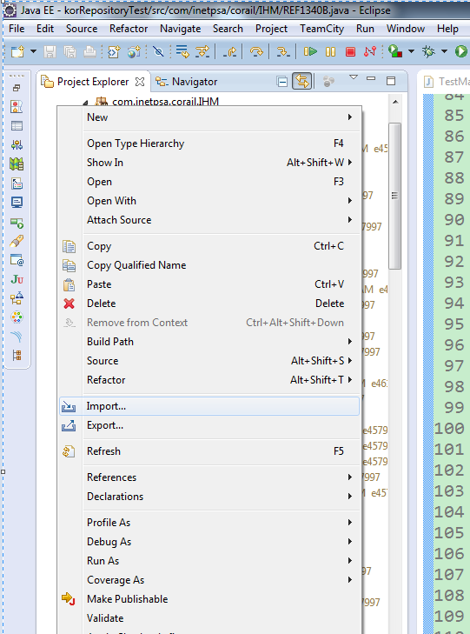

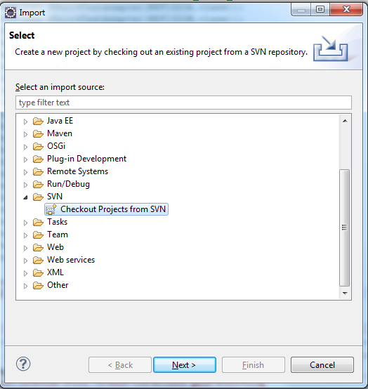

1. Choose a path to load the project, click on the Next button.

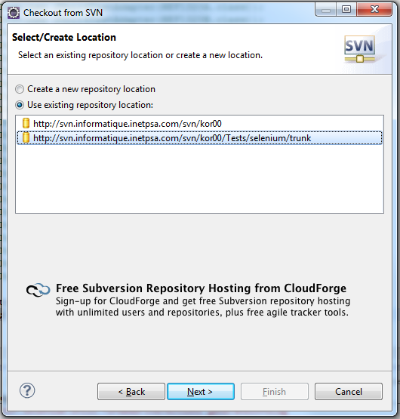

1. Click the project name which will be loaded, click on the Next button.

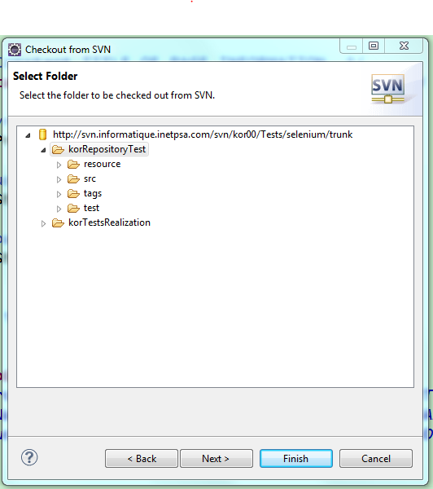

1. Choose the first radio is to rename the project. Choose the second radio is to use the project name on SVN. Click on the Finish button, the project is loaded successfully.

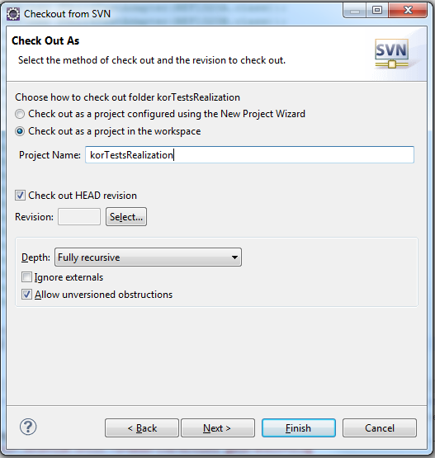

1. Configure maven
   1. Click the icon right to the run button，click External Tools Configurations….

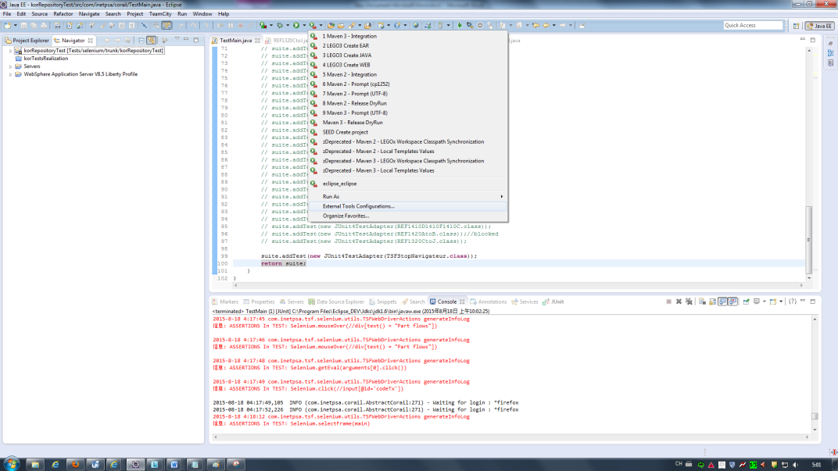

* 1. Configuration parameter

${MVN_BIN} ${workspace_loc:korRepositoryTest} -U clean eclipse:clean eclipse:eclipse

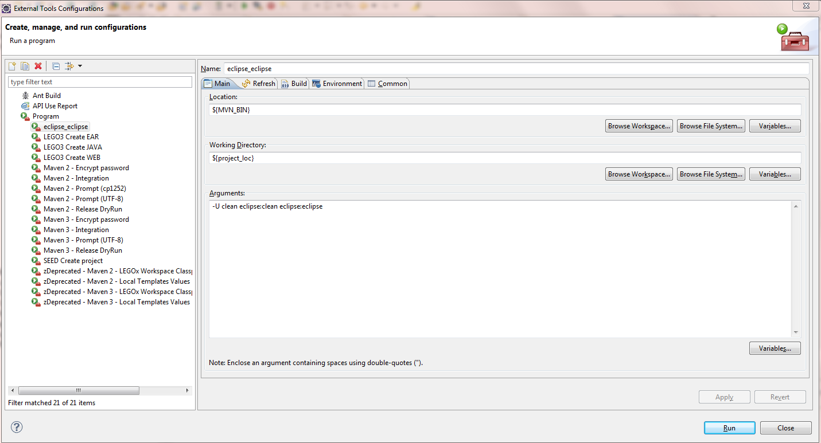

Click on the fourth Tab----> Enviroment

MAVEN_OPTS -Dfile.encoding=UTF-8 -Xms512m -Xmx1024m

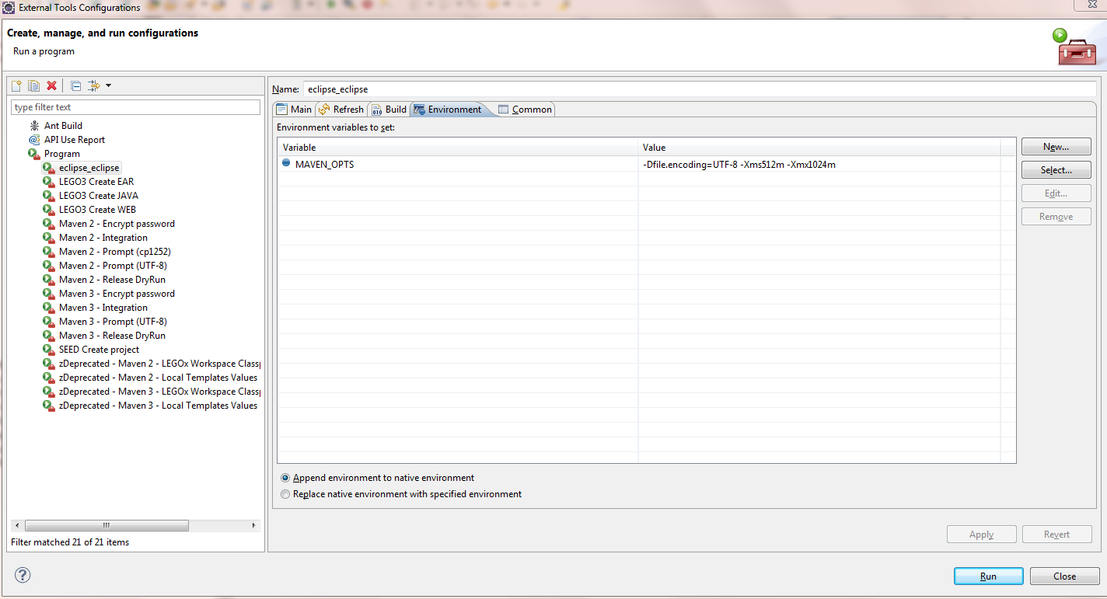

Click on the run button.

* 1. Some errors may occur in the process of Maven update.

·if it appears the following information during the process of install.

Caused by: Unable to get dependency information: Unable to read the metadata file for artifact 'com.google.code.gson:gson:jar': Invalid JDK version in profile 'doclint-java8-disable': Unbounded range: [1.8, for project com.google.code.gson:gson

com.google.code.gson:gson:jar:2.3

Find the file gson-2.3.pom what is under the path of Project Maven warehouse, open it and add the “)” behind the [1.8,

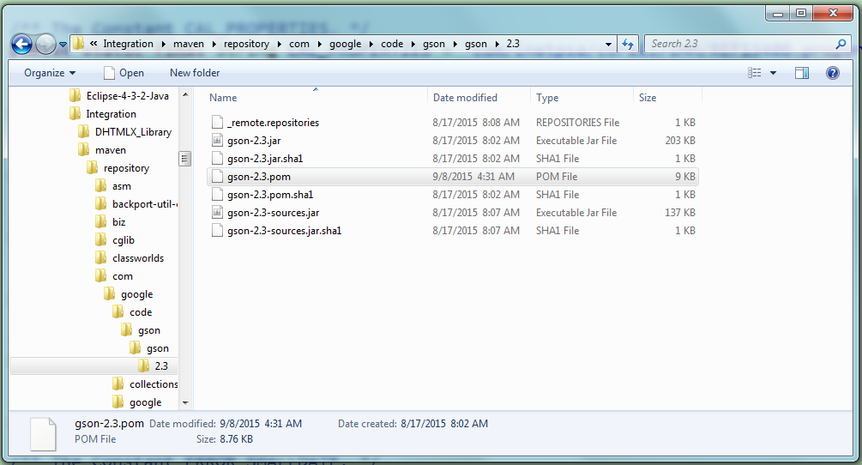

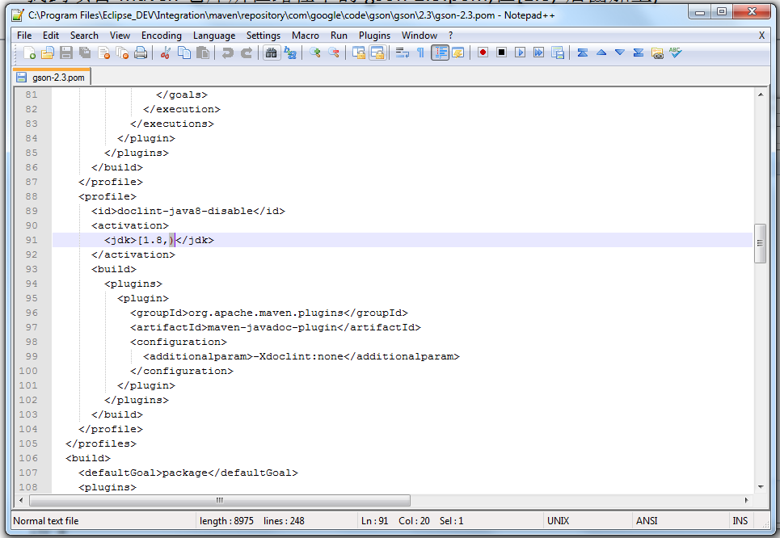

·Different versions of Jdk

First to check the version of jdk on the local computer, click Window---->preferences---->compiler--->Configure Project Specific Settings….--->click the project name--🡪click the ok button

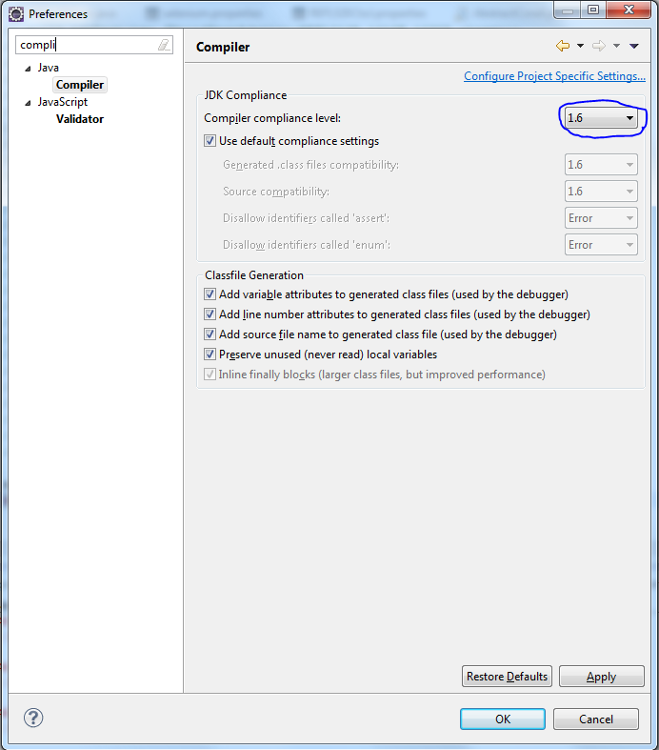

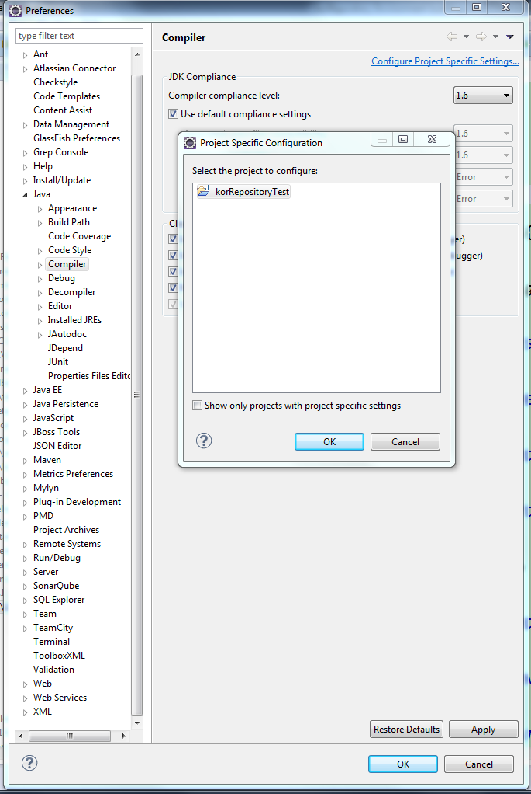

Check checkbox, Check that this version of JDK is consistent with the one just now, click on the ok button.

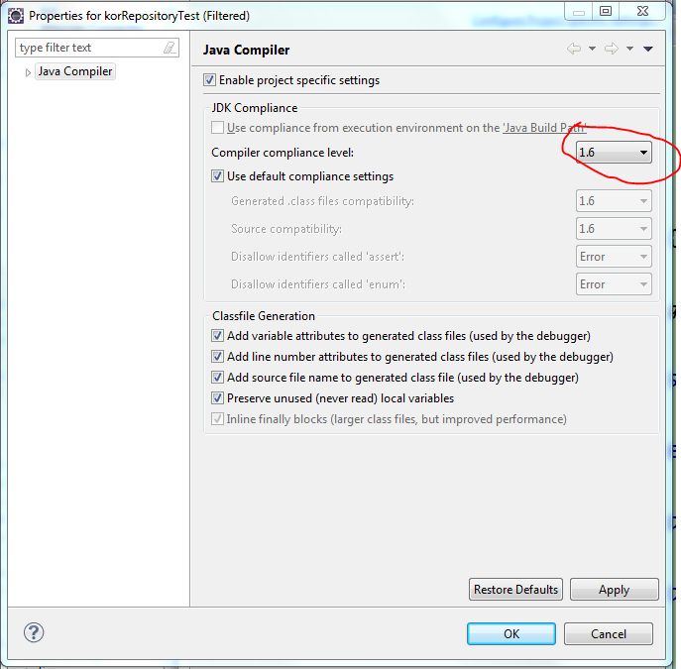

Right-click on the project--->Properties--->check checkbox, check the version of jdk is the same , if not, modify it, click on the ok button to finish.

